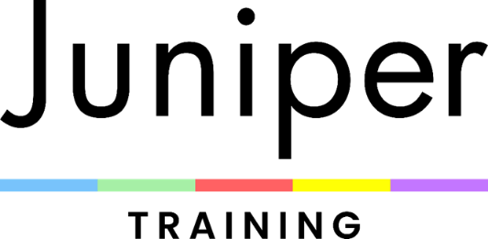

Access & Participation Statement

Valid from | December 2025
Approved by Board and Governors | December 2025

Juniper Training Ltd is committed to providing Higher Education opportunities for students from all backgrounds in order that they can progress into employment with the knowledge, skills and confidence they need to be successful.

We recognise that students will not enter higher level education from the same starting points and our entry criteria and admissions process are designed to offer university level education to applicants who may not have been academically successful in school or who may not have followed traditional routes into higher education.

In line with our strategy and mission, widening participation is at the forefront of everything we do to engage with groups who would not otherwise enter and benefit from higher education. Our engagement with students, families and local communities is deep-rooted and substantial and supports social and community cohesion in the area. Juniper Training has a key role to play in raising aspirations and awareness of the educational, progression and subsequent employment and study opportunities available.

At Juniper Training, we define widening participation criteria as: lower socio-economic groups; learners from areas of deprivation where participation is low; learners with a disability; care leavers and looked after children; young carers; ethnic minorities and other groups under-represented in higher education.

We believe our focus will continue around the whole student experience ensuring students are prepared to progress into, and through HE, and on to employment or further study. With a focus on employability and student outcomes, we will continue to work with employers to create curriculum to meet the needs of individuals, the community and business.
Retention and student outcomes remain central; we will continue to enhance our support infrastructure, ensuring that we target resources effectively

We undertake that you will be offered a place on a Higher Education programme based on your ability and enthusiasm for your subject, not based on background, experience or personal circumstances. We will help you to develop the skills, knowledge and behaviours you will need to find employment in your chosen profession, or progress to further study. We will offer opportunities to give feedback on your course and value your views and comments about how we can improve our service offered both formally and informally. The quality of our delivery and your experience is of utmost priority and we will continually review and improve our practices to ensure that we are effective, efficient and transparent in our methods of supporting all students in their journey to success.

